Footpress Pneumatic Lifter Jack

Jacks have long been used for lifting vehicles for repairing. Screw mechanism and hydraulics are the 2 major mechanisms that have long been used in lifting jacks. However there are few problems involved in these lifting jack mechanisms:
- Screw mechanism lifting is very slow
- Screw mechanism requires high oiling and is at risk of getting stuck
- Hydraulic system requires hydraulic oil for working which is very costly
- There are chances of leakage and is difficult to repair
Well we hereby propose a mechanism that solves all these issues by making use of air pressure for pneumatic lifting. This makes the lifting process faster, as well as effortless using a pneumatic pump. User just needs to foot press the pup to achieve the lift.
Additionally the jack dosen’t have require any hydraulic oil to work, it uses compressed air to achieve the lift. To lower the vehicle the air is merely released using a switching air valve. This allows for easy lifting and lowering mechanism for objects upto 150kg.
The system makes use of a pneumatic piston with directional valve, pneumatic foot pump, piping and fittings to develop this system. To start the lifting user must place the jack under the object to be lifted.
The direction valve Is now to be switched to the lifting direction. This drives the pump air flow through the pipe connected to pushing end of pneumatic piston. As the user presses the foot pump compressed air builds up on the pushing end thus pushing the piston stroke outwards and lifting the object.
To lower the object user needs to switch the valve to other side. This drains out the air pressure from the piston thus lowering the object. Thus the pneumatic jack allows for an oil less, maintenance less lifting jack mechanism.

Components
- Pneumatic Piston
- Air Pump
- Side Support Rods
- Switching Valve
- Pipes and Joints
- Base Frame
- Supporting Frame
- Mounts and Joints
- Nuts and Bolts
- Screws and Joints

Block Diagrams

Side View
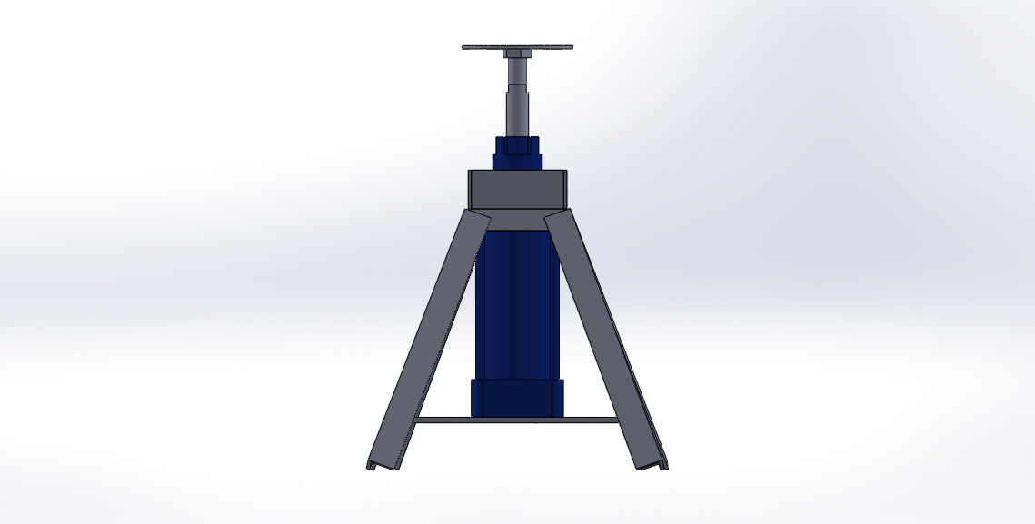

Top View
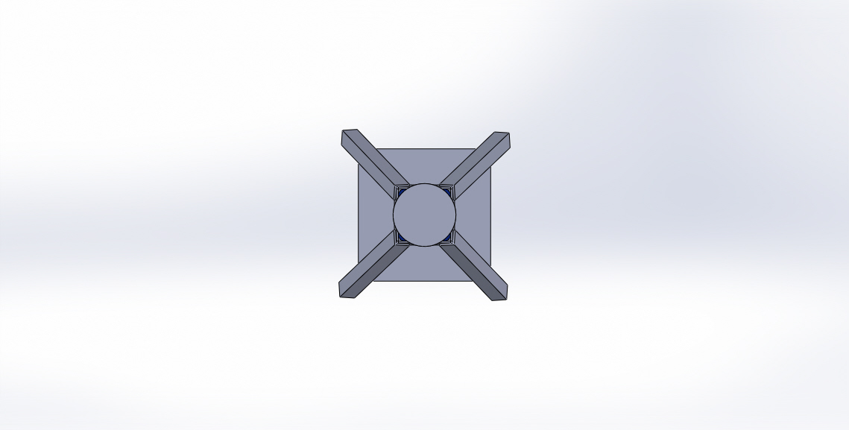

3D Views
